FIGURE 1: Number of weekly COVID-19 tests during school year (2020-2021) and (2021-2022) for different age groups. School holidays are marked in gray, and COVID-19 waves are marked in light pink. A 7-day running average was calculated.

FIGURE 2: Cases per 100,000 population during school year (2020-2021 [2:A]) and (2021-2022 [2:B]) for different age groups. School holidays are marked in gray, and COVID-19 waves are marked in light pink. A 7-day running average was calculated. The number of weekly cases was compared to the CDC indicator for risk of transmission in schools.

Figure 2:A

Figure 2:B

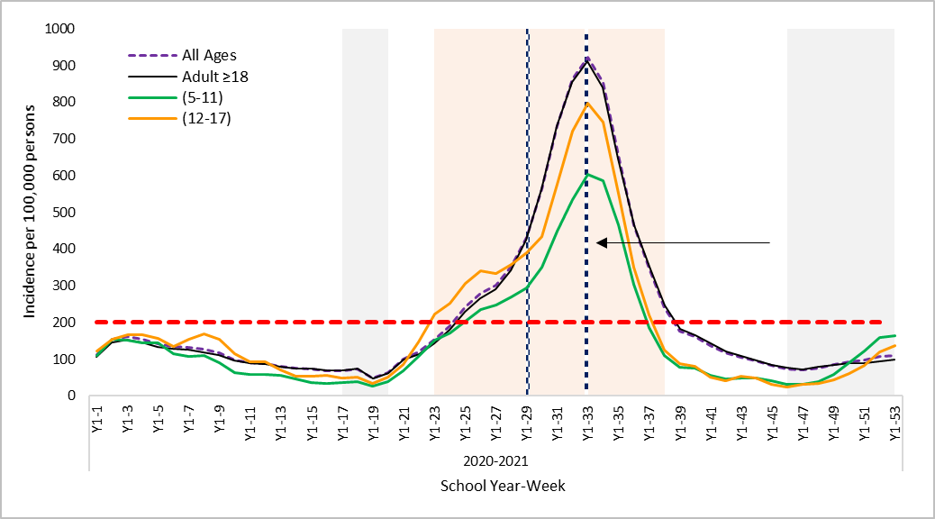

30% on-campus attendance

100% online school

CDC highest risk of transmission (>200 cases per 105 persons)

Qatar reimposes restrictions to curb the 2nd wave

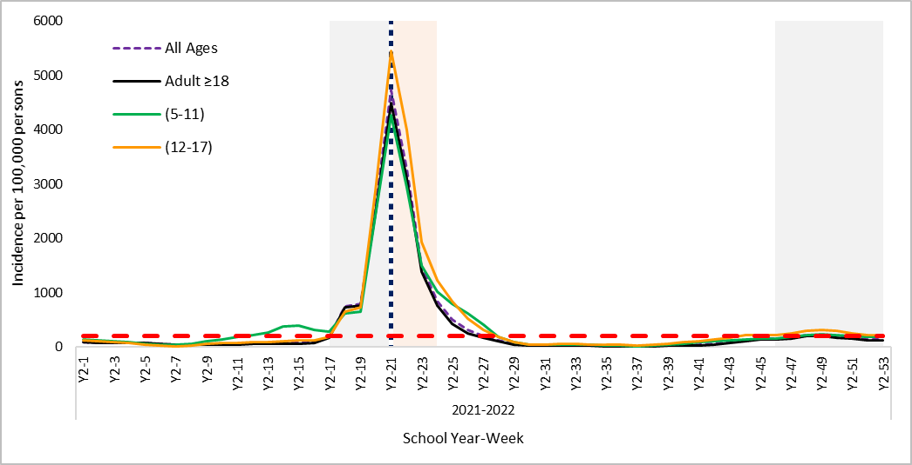

CDC highest risk of transmission (>200 cases per 105 persons)

100% online school

Figure 3:A

Figure 3:B

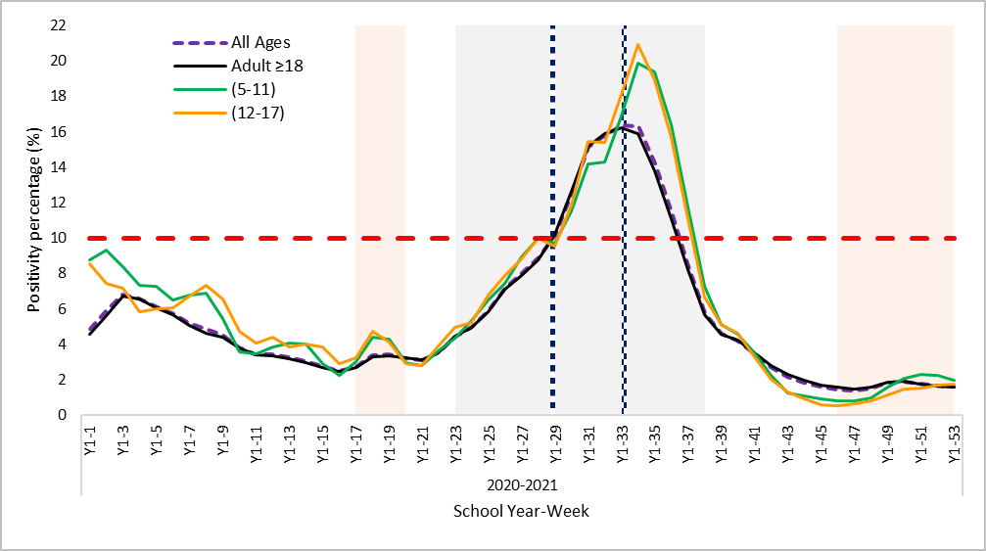

30% on-campus attendance

100% online school

CDC highest risk of transmission (>10% positive RT-PCR)

Qatar reimposes restrictions to curb the 2nd wave

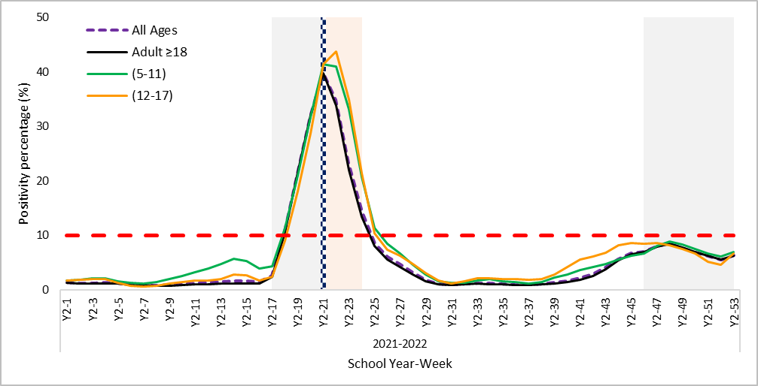

100% online school

CDC highest risk of transmission (>10% positive RT-PCR)

FIGURE 3: Weekly positivity rate for COVID-19 during school year (2020-2021 [2:A]) and (2021-2022 [2:B]) for different age groups. School holidays are marked in gray, and COVID-19 waves are marked in light pink. A 7-day running average was calculated. The number of weekly cases was compared to the CDC indicator for risk of transmission in schools.